Project Proposal

Prepared by: Tifton 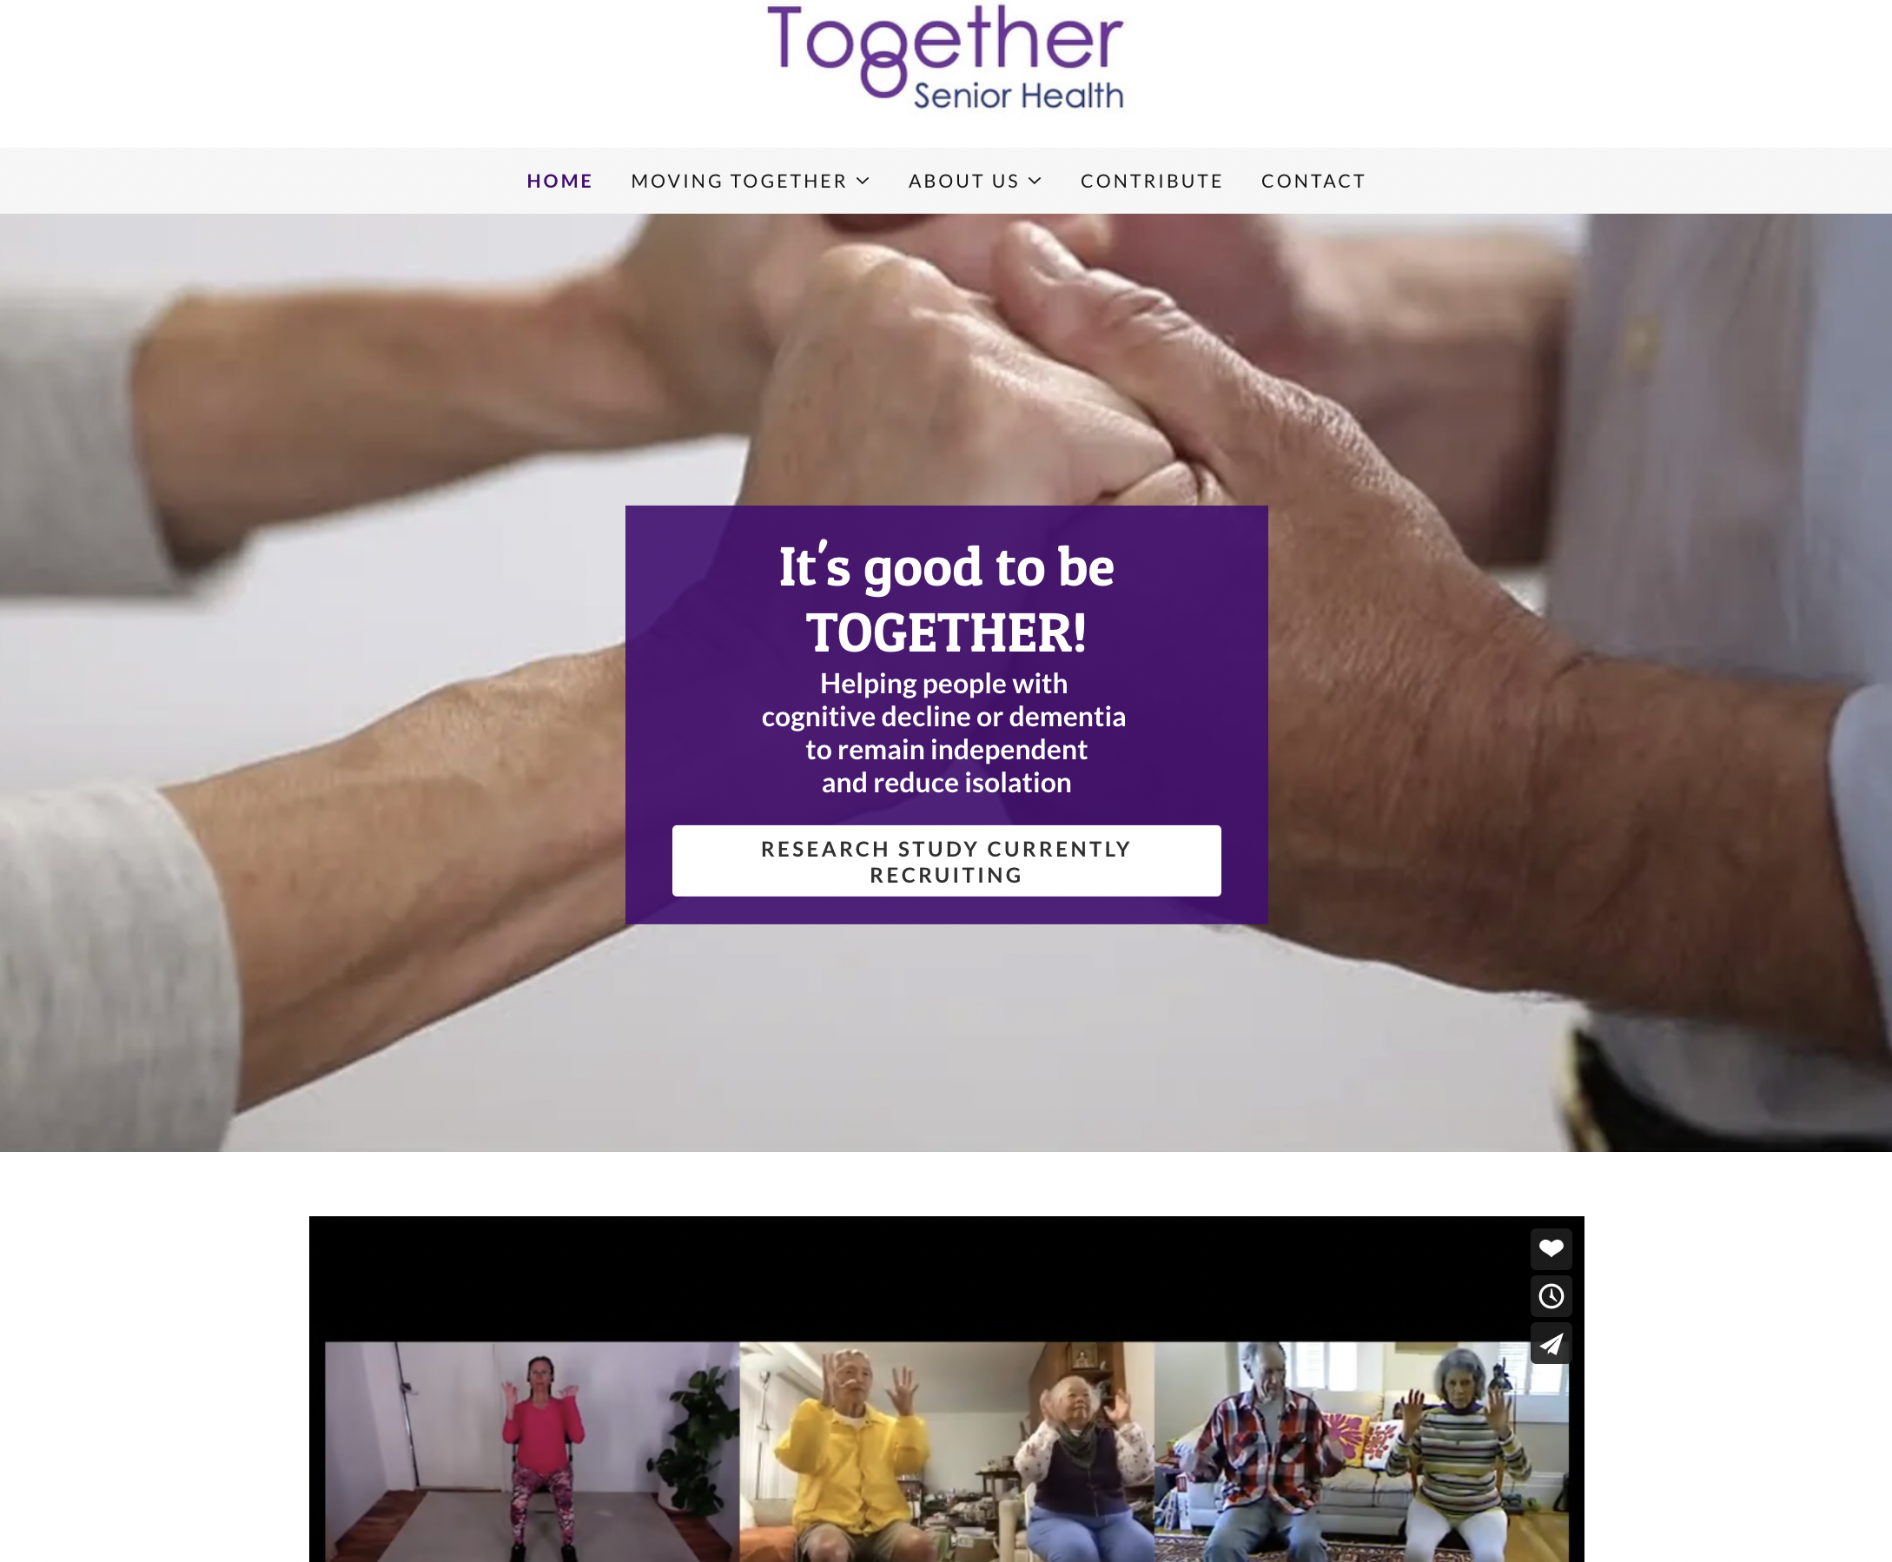partners

Tifton partners

September 13, 2021

Proposal number: 09-13-2021

# Executive Summary

## Objective

To improve and optimize Together Senior Health’s MVP that was built by using Agora 3.x and Angular / Flutter technologies, support with analysis and solutions research of the existing codebase and project architecture, design and develop more innovative and robust real-time video/audio communication platform.

## Requirements

To get started

* Please accept our proposal on upwork at the rate of $100/hr
* I’ll accept on my side and then we are ready to start.

I’ll need

* Please invite me to slack or your team messaging application.
* Access to existing MVP codebase.
* Any documentation with setup guideline if you have it.
* If you have an agency account on Agora.io, you should add me as a team Tifton partners.

Tifton partners

* Access to dev hosting server via ssh or root credential.
* Setup a kanban board on Jira confluence.

## Deliverables

1. Agora web SDK update from 3.x to 4.x (mainly Chrome browser)

2. Investigate, diagnose and improve audio quality in the current AV classroom (mainly web browser version and 3. could include the iPad app)

3. Implement audio and video, network QoS checks

4. Safari browser support

## Project Outline

The current Together’s MVP was built using Angular, Flutter, WebRTC / Agora (3.x) and deployed via CI/CD tools such as Git/Gitlab, Jenkins and AWS. There are running applications of web (chrome only) and iPad.

# Budget

## Analysis & Improvement ( MVP )

During the first stage, we’ll plan the main work flow and tasks which will focus on the existing MVP codebase for analyzing and improving the audio/video for the classroom.

Tifton partners

| Description | Timeline (week) |
| --- | --- |
| Machine Setup | 0.5 |
| Agora web SDK update from 3.x to 4.x (mainly Chrome browser) | 1.5 |
| Investigate, diagnose and improve audio quality in the current AV classroom (mainly web browser version) | 3 |
| Implement audio and video, network QoS checks | 1 |
| Safari browser support | 2 |
|  |  |
| Total | 8 |

## Solution Architecture & Optimization ( next releases )

## Mobile Apps ( native iOS and Android version )